

Politecnico di Milano

A.A. 2015-2016

Software Engineering 2: “myTaxiService”

Test Plan Document

Luiza Bentivoglio, Michele Cantarutti

22 January 2016

Summary

**1. INTRODUCTION ............................................................................................................4**

1.1 REVISION HISTORY ......................................................................................................................4

1.2 PURPOSE AND SCOPE ......................................................................................12

1.3 LIST OF DEFINITIONS AND ABBREVIATIONS ..........................................................................4

1.4 LIST OF REFERENCE DOCUMENTS ......................................................................................12

**2. INTEGRATION STRATEGY ................................................................................4**

2.1 ENTRY CRITERIA ......................................................................................................................4

2.2 ELEMENTS TO BE INTEGRATED ......................................................................................12

2.3 INTEGRATION TESTING STRATEGY ......................................................................................12

2.4 SEQUENCE OF COMPONENT/FUNCTION INTEGRATION ........................................................12

**3. INDIVIDUAL STEPS AND TEST DESCRIPTION .............................................8**

**4. TOOLS AND TEST EQUIPMENT REQUIRED .....................................................18**

**5. PROGRAM STUBS AND TEST DATA REQUIRED ...............................................18**

**1. Introduction**

1.1 REVISION HISTORY

Ascoltare prof.

1.2 PURPOSE AND SCOPE

The purpose of this document is to explain to the development team what to test, in which sequence, which tools are needed for testing, which stubs, drivers, oracles need to be developed and to describe the plans for testing the integration of the created components for the myTaxiService project. …da aggiungere scope

1.3 LIST OF DEFINITIONS AND ABBREVIATIONS

Prendere da rasd.

1.4 LIST OF REFERENCE DOCUMENTS

As references for this document we used:

* The project description, that has been provided to us
* Our RASD document
* Our Design document

**2. Integration Strategy**

2.1 ENTRY CRITERIA

We can consider the tests successful.

2.2 ELEMENTS TO BE INTEGRATED

The figure below shows the components that form the myTaxiService system. The arrows represent the order of integration. i.e. integration testing.

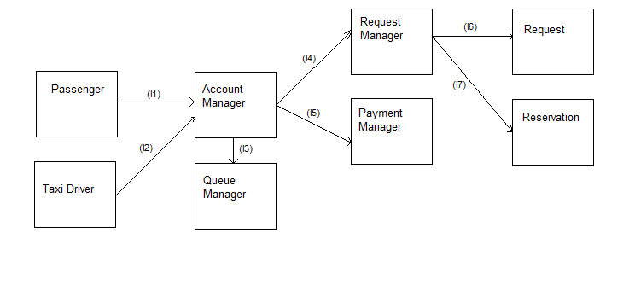

**Integration Tests of the dispatcher-software**

|  |  |  |
| --- | --- | --- |
| **ID** | **Integration Test** | **Paragraphs** |
| I1 | Passenger -> Account Manager | 2.4.1 3.1 |
| I2 | Taxi Driver -> Account Manager | 2.4.2 3.1 |
| I3 | Account Manager -> Queue Manager | 2.4.3 3.2 |
| I4 | Account Manager -> Request Manager | 2.4.4 3.2 |
| I5 | Account Manager -> Payment Manager | 2.4.5 3.2 |
| I6 | Request Manager -> Request | 2.4.6 3.2 |
| I7 | Request Manager -> Reservation | 2.4.7 3.2 |

2.3 INTEGRATION TESTING STRATEGY

We intend to test the modules that make up our system by using a bottom-up approach, which means that the integration testing will start at the bottom level and we can grant that the basic parts of our system are working from the beginning.

2.4 SEQUENCE OF COMPONENT/FUNCTION INTEGRATION

**2.4.1 Integration test case I1**

|  |  |
| --- | --- |
| Test Case Identifier | I1T1 |
| Test Item(s) | Passenger -> Account manager |
| Output Specifications | Create typical Passenger input |
| Output Specifications | Check if the correct functions are called in the Passenger Object |
| Environmental Needs | Passenger driver |

**2.4.2 Integration test case I2**

|  |  |
| --- | --- |
| Test Case Identifier | I1T2 |
| Test Item(s) | Taxi driver -> Account manager |
| Output Specifications | Create typical Taxi driver input |
| Output Specifications | Check if the correct functions are called in the Taxi driver Object |
| Environmental Needs | Taxi driver driver |

**2.4.3 Integration test case I3**

|  |  |
| --- | --- |
| Test Case Identifier | I2T1 |
| Test Item(s) | Account Manager -> Queue Manager |
| Output Specifications | Create typical Account Manager input |
| Output Specifications | Check if the correct functions are called in the Account Manager |
| Environmental Needs | I1-I2 succeeded |

**2.4.4 Integration test case I4**

|  |  |
| --- | --- |
| Test Case Identifier | I3T1 |
| Test Item(s) | Account Manager -> Request Manager |
| Output Specifications | Create typical Account Manager input |
| Output Specifications | Check if the correct functions are called in the Account Manager |
| Environmental Needs | I1-I2 succeeded |

**2.4.5 Integration test case I5**

|  |  |
| --- | --- |
| Test Case Identifier | I4T1 |
| Test Item(s) | Account Manager -> Payment Manager |
| Output Specifications | Create typical Account Manager input |
| Output Specifications | Check if the correct functions are called in the Account Manager |
| Environmental Needs | I3-I4 succeeded |

**2.4.6 Integration test case I6**

|  |  |
| --- | --- |
| Test Case Identifier | I5T1 |
| Test Item(s) | Request Manager -> Request |
| Output Specifications | Create typical Request Manager input |
| Output Specifications | Check if the correct functions are called in the Request Manager |
| Environmental Needs | I4 succeeded |

**2.4.7 Integration test case I7**

|  |  |
| --- | --- |
| Test Case Identifier | I6T1 |
| Test Item(s) | Request Manager -> Reservation |
| Output Specifications | Create typical Request Manager input |
| Output Specifications | Check if the correct functions are called in the Request Manager |
| Environmental Needs | I4 succeeded |

**3. Individual steps and test description**

**3.1 Integration test procedure TP1**

|  |  |
| --- | --- |
| **Test Procedure Identiﬁer** | **TP1** |
| **Purpose** | This test procedure veriﬁes wether the dispatcher software:  • can handle command-line input  • can handle account manager input  • can handle taxi driver input  • can output requested information to a passenger  • can output requested information to a taxi driver |
| **Procedure Steps** | Execute I3-I4 after I1-I2 |

**3.2 Integration test procedure TP1**

|  |  |
| --- | --- |
| **Test Procedure Identiﬁer** | **TP2** |
| **Purpose** | This test procedure veriﬁes wether the dispatcher software:  • can handle account manager input  • can handle request manager input  • can output requested information to the account manager  • can output requested information to request manager |
| **Procedure Steps** | Execute I6-I7 after I4 |

**4. Tools and test equipment required**

Prendere dalle slide

**5. Program stubs and test data required**

Esempio di database -> esempio di dati di un utente, del tassista, della code delle zone, (tipo, “deve esserci un utente con questi dati...deve esserci tassista con....)